Chapter 3, Problem 34.

Determine which of the circuits in Fig. 3.83 is planar and redraw it with no crossing branches.

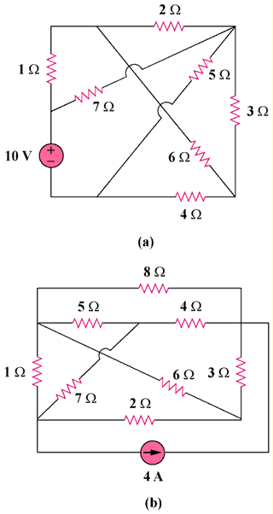

Figure 3.83
For Prob. 3.34.

